## Linux Commands Utilities

1. Which command is used to know the current working directory?

**Ans: PWD:** stands for present working directory. It is used to display current directory you are in within the filesystem.



1. How would you find out its contents?

**Ans: Cat:** commonly used to display, combine, create file. Commonly used to read the file contents

**Or**

**ls:** It is used to list the files and directories in a specified directory**.**



1. Identify the commands with inputs to do the following
   1. create a directory d1
   2. create a subdirectory d2 in d1
   3. change to directory d2
   4. create an empty file “f1.txt”
   5. display the contents of “f1.txt”
   6. view the contents of d1 from current directory d2

**Ans: mkdir d1 d1/d2**

**cd d1/d2**

**touch f1.txt**

**cat f1.txt**

**ls ..**

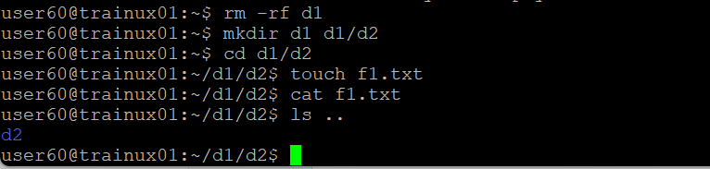



1. Use the ls command with its options. How will you identify directories from the listing?

**Ans: ls -la**

1. Use ls to do the following
   1. List files with single character names.
   2. List hidden files also. [ Note : Hidden files are files having name started with a “.” ]
   3. Suppose there are files tb1.1, tb2.1, tb3.1, ….tb10.1. Write command to list all the files [Hint: use wild card characters]

**Ans: ls ?**

**ls -la**

**ls tb*.1**

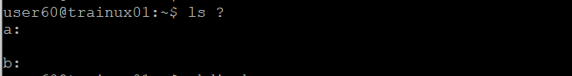

1. Write the command to list all files in descending order of their size.

**Ans: ls -lS**

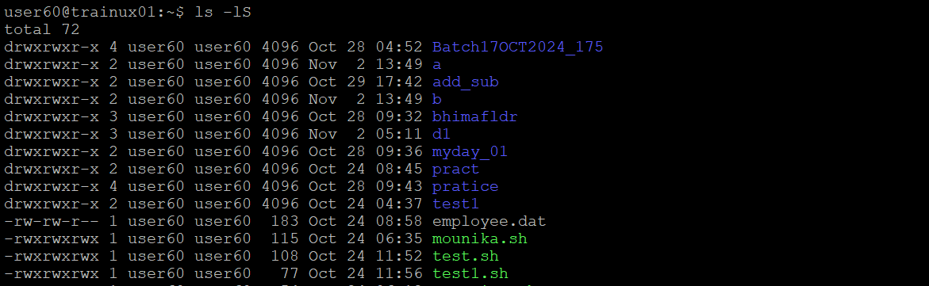

1. Suppose there are files temp1, temp2, temp3. Write command to remove the files without listing them explicitly

**Ans: rm -rf temp1/temp2/temp3**



1. Which command is used to list top few lines in the file?

**Ans: head f1.txt**

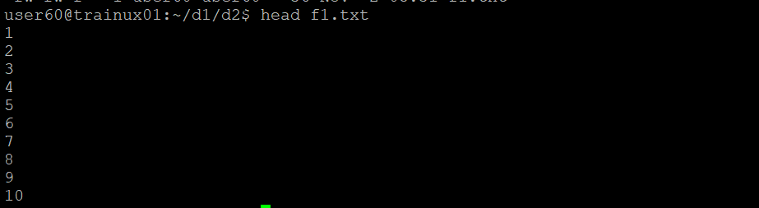

1. Create a directory “testdir”

**Ans: mkdir testdir**



1. Use cp command to do the following
   1. Copy the file tb1.1 (created above) in the same directory.
   2. Write a command to copy all the files i.e tb1.1,tb2.1,tb3.1,…..tb10.1 in a new directory –“new”
   3. Create a subdirectory in new in named“new1”.
   4. Write a command to copy selectively only tb2.1, tb6.1, tb7.1 and tb10.1 in the directory new1.
   5. Write a command to copy the entire directory “new” to a directory “newprogs”. [Note : use the –R option of “cp” command ]

**Ans: cp tb1.1 tb1.1_copy**

**cp -rf tb*.1 new/**

**mkdir new new/new1**

**cp -rf tb2.1 tb6.1 tb7.1 tb10.1 new1/**

**cp -R new newprogs**

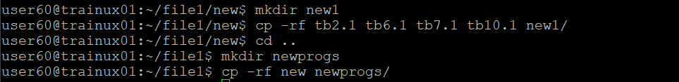

1. Find out the difference between
   1. ]“mv” & “cp”
   2. “rm”, “rmdir”
   3. “mkdir” and “mkdir -p”

**Mv & cp:**

**Mv(move):** moves files or directory from one location to another. The original file or directory is removed from source and added to the destination. It can be used to rename files.

**Cp(copy):** Copies files or directories from one location to another. The original file or directory remains in the source location, and a duplicate is created at the destination.

**rm vs. rmdir**

**rm (Remove):** Deletes files or directories. To delete directories, the -r (recursive) option must be used, as rm alone only removes files.

**rmdir (Remove Directory):** Deletes empty directories only. If a directory contains files or other directories, rmdir will not work.

**mkdir vs. mkdir -p**

**mkdir (Make Directory):** Creates a new directory. If the specified directory’s parent does not exist, it will throw an error.

**mkdir -p:** Creates the specified directory along with any necessary parent directories. If any part of the path does not exist, it creates it automatically.

1. Use a single command rmdir once to remove “testdir” and all its sub directories and files created above.

**Rm -rf testdir**

1. Which command is used to get the manual information of a command?

**Man:** man is a built-in help system in linux.

Man is a short for manual

Man page is documentation

1. If you are not able to change to a directory what could be the likely cause?

Ans: Incorrect path

You might lack the necessary read or execute permissions to access

Target is a file,not a directory

1. Explain the differences among the following commands:  
                 a. cd / 🡪to change root directory

  b. cd .. 🡪change to the current directory

  c. cd 🡪change directory to the user home directory

  d. cd ../..   🡪change to the parent of the parent directory